Chapter 1, Solution 9

(a) 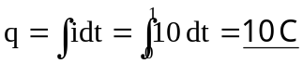

(b) 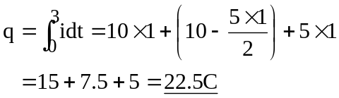

(c) 